Exercise

If you haven't already noticed, the program has a bug. When the listbox is empty and the user clicks the listbox, an *IndexError* is generated in the terminal:pasted-image.tiff

Why does this error happen?

Well, everything starts with the user clicking on the listbox. Clicking the listbox executes the following code:

list1.bind('<<ListboxSelect>>',get_selected_row)

That code calls the get_selected_row  function: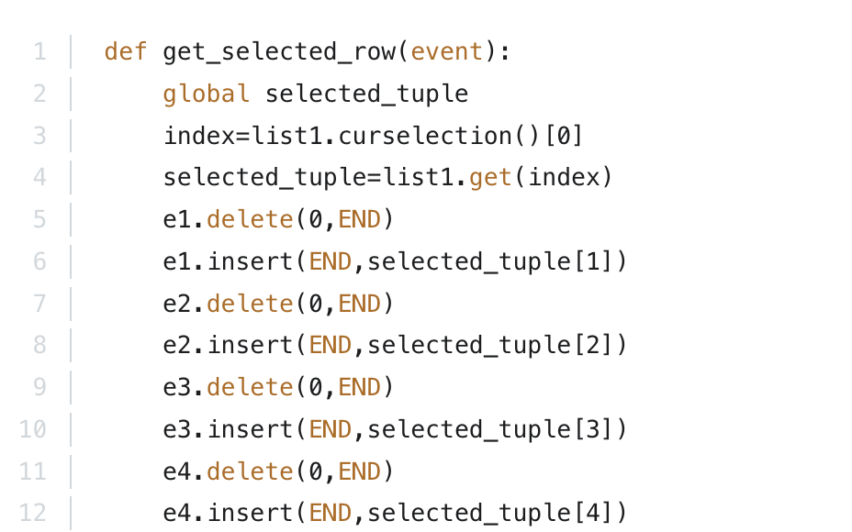

Since the listbox is empty,  list1.curselection()  will be an empty list with no items. Trying to access the first item on the list with [0]  in line 3 will throw an error because there is no first item in the list.

Try to fix that bug. The next lecture contains the solution.